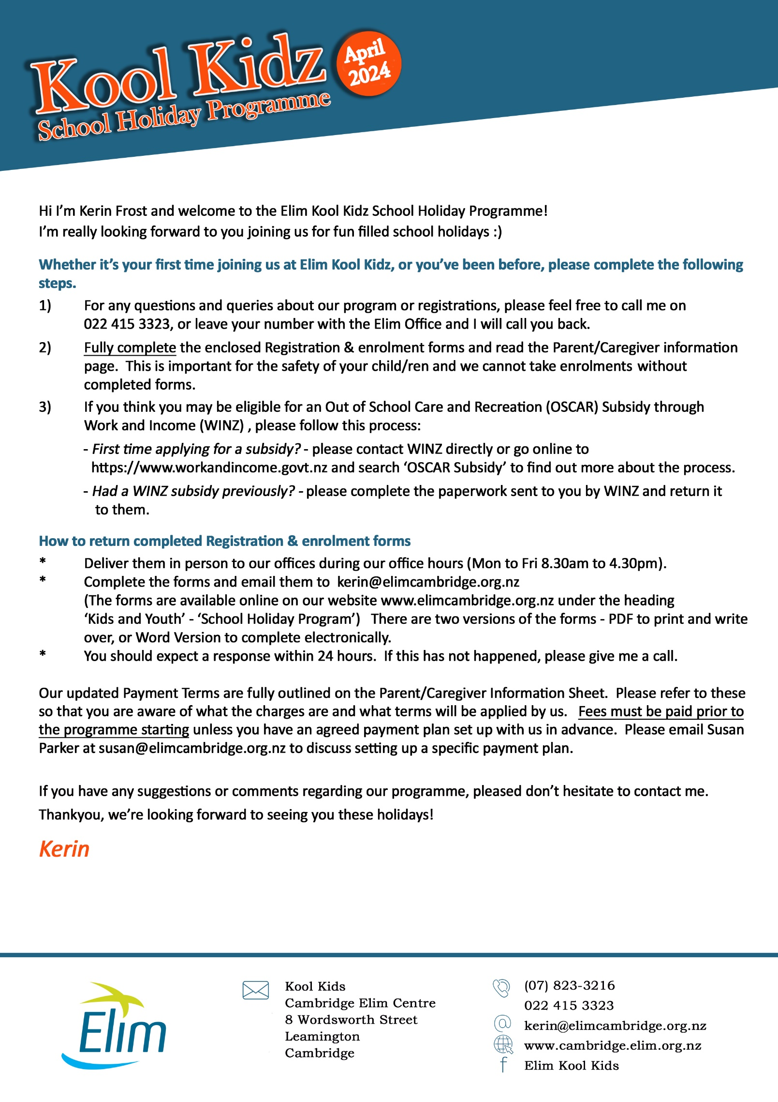

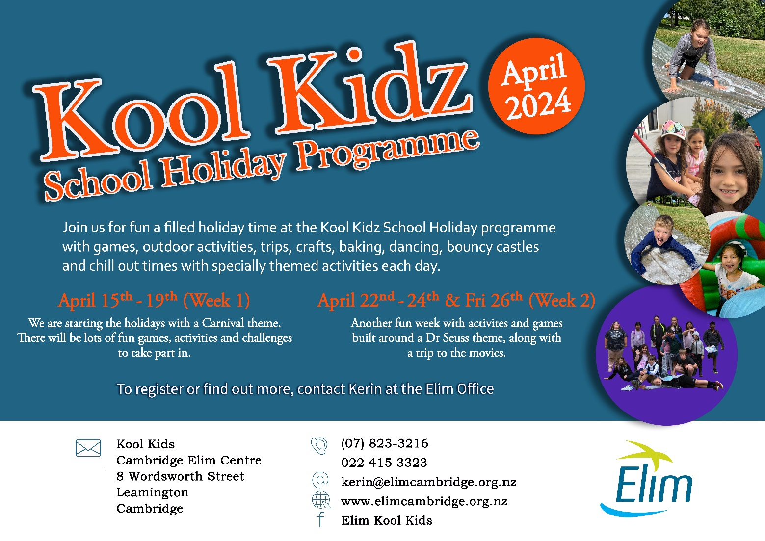
PARENT / CAREGIVER INFORMATION
Welcome to Kool Kidz School Holiday Programme (ages 5 to 13)
April 2024
This Parent/Caregiver Information document is for you to keep. Please read as it contains important information.
Operating Dates & Hours
- Dates:
  - Week 1: Monday 15th April to Friday 19th April 2024.
  - Week 2: Monday 22nd April to Wednesday 24th April, and Friday 26th April 2024.

- Hours: A full day is from 7:30 am to 5:30 pm each day.
- Morning Drop-off: Please drop your child off at our Centre (8 Wordsworth Street, Leamington, Cambridge) ideally between 7:30 am and 9:00 am. Please do not drop your child off before 7:30 am as there will be no-one present to supervise them. If a child is going to be late (after 9:00 am) please do give the Supervisor a phone call to let us know.
- Afternoon Pick-up: Please pick up your child before 5:30 pm. Fees are charged when children are not collected by this time (detailed in Payment Terms later in this document).
- We need prior notification from you if you plan to send a different person to pick up your child. If a person arrives to collect your child and we have no knowledge of this person, then we are obliged (for the safety of your child) to keep the child in our care until you have been located for consent.

Programme
Children participate in organised activities including indoor and outdoor games, sports, crafts, baking, team challenges and free play. We include some limited video game time, only with prior Parent/Caregiver approval. You can follow us on Elim Kool Kidz Facebook page.

Registration & Enrolment
We need Registration and Enrolment Forms to be completed in full for each holiday program.
Registration forms give us all the information we need to know about your child/ren, including emergency contacts, allergies, medical conditions. Even if your child has attended our programmes previously, it is very important that we have up-to-date information, in the interest of your child’s safety and well-being.
Enrolment Forms indicate the dates your child/ren are registered for including any trips. Enrolment is finalised only upon completion of the relevant forms and payment of fees in accordance with our Payment Terms.
This information will only be used for the purpose of your child/ren’s enrolment and safety during our programme. Information may be accessed by the Ministry of Social Development for auditing purposes.

Programme Fee
- One of the following two options, depending on how many days your child is booked for:
- $42.00 per child per day.
- $185.00 per child for one full week (Monday to Friday in the same week) (equivalent to a $25 discount).

- In addition to the base fee above there will be any applicable trip fees for Wednesday trip days. These are set before each holiday programme as the trips differ programme to programme.
- We only accept bookings for full days and not for half or part days; anything less than a full day creates
difficulties in arranging adequate staffing supervision.
- Bookings are taken on a first in basis, inclusive completed enrolment and fees paid.
- Family discount: 50% discount applies to the third child in a family attending the same session. This discount does not apply for WINZ subsidised families.
- Terms of Payment are detailed fully later in this document.

What to bring
- Suitable clothing for the day, if sunny provide sun cover clothes (including a hat)
- Sun block protection (Surf Life Saving sunblock is provided)
- Food for morning tea, lunch, and afternoon tea, plus a Drink bottle. If your child has any specific allergies, health or dietary requirements please let us know in the interests of their health and wellbeing.

Signing your child in or out
Please sign your child in and out using our computerised system at the Kool Kidz sign in area. This must happen each day when you drop off or pick up your child and indicates the time your child is dropped off or picked up. This is extremely important as:
- It enables us to know with certainty that there are no missing children.
- OSCAR funding which helps us keep the price down for parents/caregivers, requires we have and keep accurate documentation with these details.

Absences
Once your child is enrolled, we need to be notified by the Parent/Caregiver if they are not going to attend, for whatever reason. Please phone Kerin on 022-415-3323 and leave a message. If we have not been notified and your child does not arrive on site, we will contact you in the first instance. Your child’s safety is paramount to us!

Sick Children
Please do not send along sick children, as we do not have the facilities to care for them. If a child becomes ill during programme hours, Parent/Caregivers will be called and asked to collect them. If you have any queries or concerns, the Supervisor is available to assist you.

Behaviour Management
We use behaviour management techniques that encourage positive self-esteem. It is our goal to ensure that children and families experience an environment where they are safe, secure, respected and their dignity is protected. This is done through the use of positive reinforcement and a stimulating and varied programme to ensure against boredom. Every effort will be made to help your child settle into the programme. However, if a child’s behaviour is consistently harmful to other children, you will be asked to remove him/her from the programme.

Video Games
From time to time we have video games that we bring out (X-Box & PlayStation). We are very strict on the type of games that we allow to be played by children whilst in our care. We are also aware that families have different

guidelines for their children as to the availability of playing these types of games and we wish to respect those boundaries. Please indicate your preferences on the Registration Form.

Policies and Procedures
Please see the Supervisor if you wish to view our Policies and Procedures. It contains detailed information on health and safety, making complaints, employment practices, etc…

Complaints
The programme has a complaints procedure. If you have any problems please approach the Supervisor, or if necessary, Community Trust Board chairman, and they will be happy to assist you. If you wish to report a serious concern, you can contact the Oranga Tamariki at 0508 FAMILY (0508 326 459).

Child Safety
The programme has a detailed child protection policy, which includes the reporting of any suspected child abuse to the Oranga Tamariki.

Emergencies
Our Staff are trained to deal with emergencies. In the case of a serious accident involving your child the Staff will contact you and call 111. In a civil emergency the Staff will remain at the Centre until all children are collected, unless instructed otherwise by the authorities.

Terms of Payment
- Fees
Payment for your booking must be made in advance. If this is difficult for you please contact us to set up a
payment schedule. Payment schedules must be pre-approved with our Administrator (contact susan@elimcambridge.org.nz) and must ensure that the fees are fully paid before the end of the programme.

Fees can be paid via internet banking (see Bank details below) OR paid at Elim Reception by Eftpos. We do not accept credit cards. All fees paid by Eftpos will be receipted and payments will show on the following invoice. We don’t accept cash but if this is your only option please talk with us.
Any unpaid fees after two weeks of the final day of the programme will incur a 10% administration fee unless a payment arrangement has been made with the programme management. If fees remain unpaid after three months, a debt collection procedure will be commenced with any costs of such plus the 10% administration fee added to the debt.

WINZ clients please ensure your forms are sent off prior to the programme start date so that your WINZ payments come to us in a timely manner. Please keep a copy of your WINZ forms. WINZ clients are required to pay 50% of the fee in advance when booking. This will be refunded once the WINZ subsidy is received.

As we are a non-profit organization and seek to keep our fees as low as possible, your timely payments are essential to ensure we can continue to provide this service and resource our programme.

- Changes /Absence / Cancellation / Late Pickup
- Changes: We require a minimum of seven days’ notice before changes to your child’s bookings in the School Holiday Programme can be made without charge. Deposits are non-refundable unless seven days’ notice is given.
- Cancellation fees: Full fees apply for a booked session cancelled on the day or where a child does not attend.
- Absence: Where children are absent due to medical conditions, or for a genuine emergency-based reason,
we may consider a fee discount. These will be considered on a case-by-case basis. Please contact the Supervisor to discuss this.
- Late Pickup: Should your child not be picked up by 5.30pm, a late charge will apply. Up to 15 minutes late the charge is $10.00 per child. After 5:45 pm, per 15 minutes: $10.00 for one child; $15 for two children and $20 for three or more children.

- Possibility of WINZ Assistance
WINZ offers a subsidy as a way of assistance to some Parents/Caregivers whose children attend an official OSCAR programme.

- Please contact WINZ directly if you believe you are eligible for a WINZ subsidy for this Holiday Programme or require their forms to make a subsidy application. If you would like some assistance in this process, you are most welcome to come into our Centre office and see Kerin Frost, our Kool Kidz Holiday Programme Supervisor. She can assist you in trying to determine what level of WINZ subsidy you may or may not be eligible for. Please contact Kerin in advance to make an appointment with her. Kool Kidz offers helpful advice but takes no liability or responsibility for final decisions made by WINZ.
- If you do qualify for a WINZ Subsidy, such amount can be deducted from your Programme Fee payable to us. No deposit of 25% is required if your WINZ subsidy is confirmed in writing to us prior to commencement of the programme. If not confirmed in writing, the 25% deposit remains payable.
- The Parent/Caregiver agrees full payment to Kool Kidz is their personal responsibility and commitment. No non-payment will be permitted because WINZ either declines or reduces a subsidy or the subsidy was applied for too late to determine eligibility prior to programme commencement. We therefore strongly encourage any Parent/Caregiver seeking WINZ assistance to take early action (at least 2 to 3 weeks prior to commencement of a holiday programme) to find out their eligibility for any WINZ subsidy.

- Our Bank Account Details:
The bank account for all Kool Kidz payments is:
Bank: ANZ Branch, Cambridge
Account Name: Cambridge Elim Community Trust
Account Number: 06-0301-0126141-00
Particulars: Parent’s full name
Code: Invoice number
Reference: Child’s full name

We look forward to getting to know you and your child.
KOOL KIDZ - REGISTRATION FORM - April 2024
(Hold cursor over checkboxes and click once to tick the box)
Date: Click or tap here to enter text.

Name(s) of your children:

1 Click or tap here to enter text.
D.O.B. Click or tap here to enter text.
☐M ☐F

2 Click or tap here to enter text.
D.O.B. Click or tap here to enter text.
☐M ☐F

3 Click or tap here to enter text.
D.O.B. Click or tap here to enter text.
☐M ☐F

4 Click or tap here to enter text.
D.O.B. Click or tap here to enter text.
☐M ☐F

Parent / Caregivers Primary Contact: Click or tap here to enter text.
Contact Details:
a) Home address: Click or tap here to enter text.
b) Email address: Click or tap here to enter text.
c) Telephone: Home number) Click or tap here to enter text.
Work number) Click or tap here to enter text.
Mobile number) Click or tap here to enter text.

Parent/ Caregivers Secondary Contact: Click or tap here to enter text.
Contact Details:
a) Home address (if applicable): Click or tap here to enter text.
b) Email address: Click or tap here to enter text.
c) Telephone: Home number) Click or tap here to enter text.
Work number) Click or tap here to enter text.
Mobile number) Click or tap here to enter text.

If there are several contact details, please specify whose number it is above.

Please indicate how you would prefer to be communicated with (check one):
☐ Postal Mail ☐ Email

Form continues on next page, please complete next page

People authorised to pick up your child:

Name: Click or tap here to enter text.
Name: Click or tap here to enter text.

People who specifically cannot pick up your child:

Name: Click or tap here to enter text.
Name: Click or tap here to enter text.

Emergency contacts (cannot be Parent/Caregiver):

Name: Click or tap here to enter text.
Relationship to child: Click or tap here to enter text.
Tel: Click or tap here to enter text.
Mobile: Click or tap here to enter text.

Name: Click or tap here to enter text.
Relationship to child: Click or tap here to enter text.
Tel: Click or tap here to enter text.
Mobile: Click or tap here to enter text.

Children’s Doctor: Click or tap here to enter text.
Telephone: Click or tap here to enter text.
Doctor’s Clinic: Click or tap here to enter text.
Address: Click or tap here to enter text.

Additional information: (The more information we have the better we can care for your child)
Click or tap here to enter text.

Does your child have any particular health needs we should be aware of? (include allergies)
Click or tap here to enter text.

Is there anything else we should know about in order to take good care your child?
Click or tap here to enter text.

Video Games activities

My preference is that my child (please circle one)
☐ Does not play at all
☐ For not longer than 1 hour per day
☐ Happy with your discretion.

Form continues on next page, please complete next page

Permissions (Hold cursor over checkbox and click once to tick the box)

☐ I give permission for my child to photographed/videoed for the purposes of marketing and advertising.
☐ I do not give permission for my child to photographed/videoed for the purposes of marketing and advertising.

☐I give permission for my child to photographed/videoed to be added to Elim Kool Kidz Facebook.
☐ I do not give permission for my child to photographed/videoed to be added to Elim Kool Kidz Facebook.

☐ I give permission for my child to photographed/videoed to be added to Elim Kool Kidz Instagram
☐ I do not give permission for my child to photographed/videoed to be added to Elim Kool Kidz Instagram

Signed by Parent/Caregiver: Click or tap here to enter text.
(writing your name here indicates signature)
Date: Click or tap here to enter text.

Privacy Act 2020: The information that you have supplied is necessary for the safe and effective operation of the Holiday Programme. This information may be accessed by the Ministry of Social Development during regular programme audits. You are welcome to review information pertaining to your child’s enrolment at any time.
Form continues on next page, please complete next page

KOOL KIDZ - ENROLMENT FORM - April 2024
Name(s) of children: (Please complete for each child)
First child Click or tap here to enter text. Age Click or tap here to enter text.
Week 1 Monday 15 - Friday 19 April |  |  |  |  |  | Cost at  $42/day  $185 full 5 day week Mon-Fri  $8 Cambridge Pools Trip - Wed
Days Required  (please tick) | Mon 15th  ☐ | Tues 16th  ☐ | Wed 17th  ☐ | Thur 18th  ☐ | Fri 19th  ☐ | $ Click or tap here to enter text.
Approx Drop off & Pickup Times: Click or tap here to enter text.

Week 2 Mon 22 - Wed 24 & Fri 26 April  (CLOSED ANZAC DAY Thurs 25th April) |  |  |  |  |  | Cost at  $42/day  $20 Tivoli Movies Wed Trip
Days Required  (please tick) | Mon 22nd  ☐ | Tues 23rd  ☐ | Wed 24th  ☐ |  | Fri 26th  ☐ | $ Click or tap here to enter text.
Approx Drop off & Pickup Times: Click or tap here to enter text.

Second child Click or tap here to enter text. Age Click or tap here to enter text.
Week 1 Monday 15 - Friday 19 April |  |  |  |  |  | Cost at  $42/day  $185 full 5 day week Mon-Fri  $8 Cambridge Pools Trip - Wed
Days Required  (please tick) | Mon 15th  ☐ | Tues 16th  ☐ | Wed 17th  ☐ | Thur 18th  ☐ | Fri 19th  ☐ | $ Click or tap here to enter text.
Approx Drop off & Pickup Times: Click or tap here to enter text.

Week 2 Mon 22 - Wed 24 & Fri 26 April  (CLOSED ANZAC DAY Thurs 25th April) |  |  |  |  |  | Cost at  $42/day  $20 Tivoli Movies Wed Trip
Days Required  (please tick) | Mon 22nd  ☐ | Tues 23rd  ☐ | Wed 24th  ☐ |  | Fri 26th  ☐ | $ Click or tap here to enter text.
Approx Drop off & Pickup Times: Click or tap here to enter text.

Third child Click or tap here to enter text. Age Click or tap here to enter text.
Week 1 Monday 15 - Friday 19 April |  |  |  |  |  | Cost at  $42/day  $185 full 5 day week Mon-Fri  $8 Cambridge Pools Trip - Wed
Days Required  (please tick) | Mon 15th  ☐ | Tues 16th  ☐ | Wed 17th  ☐ | Thur 18th  ☐ | Fri 19th  ☐ | $ Click or tap here to enter text.
Approx Drop off & Pickup Times: Click or tap here to enter text.

Week 2 Mon 22 - Wed 24 & Fri 26 April  (CLOSED ANZAC DAY Thurs 25th April) |  |  |  |  |  | Cost at  $42/day  $20 Tivoli Movies Wed Trip
Days Required  (please tick) | Mon 22nd  ☐ | Tues 23rd  ☐ | Wed 24th  ☐ |  | Fri 26th  ☐ | $ Click or tap here to enter text.
Approx Drop off & Pickup Times: Click or tap here to enter text.
TOTAL FEES $
Please note booking will be confirmed when payment is made.
Form continues on next page, please complete next page

Please ensure you have completed the Registration Form with details about your child including emergency contacts.
If you have any questions about the programme or wish to see a copy of the programme policy prior to signing, please do not hesitate to ask a member of staff.
I/We agree and acknowledge:
- I have read and understand the above information.
- I have read and understand the Parent / Caregiver Information document.
- I accept the Terms of Payment indicated in the Parent / Caregiver Information document.
- I understand that my booking will not be confirmed until payment is made.
- The Supervisor has my permission to arrange any necessary urgent medical treatment at my cost.
- All care will be taken to provide supervision of children attending the programme in accordance with programme policy and procedures. I acknowledge however, in signing this form, that neither the staff nor management of the programme will be liable for any loss or damage (by way of accident, injury, theft or otherwise) arising out of attendance at the programme.
- That we require a minimum of seven days’ notice before changes to your child’s bookings in the School Holiday Programme can be made without charge.
- All information kept on your child/ren will be secure and confidential. We may be required to share information with government agencies including the New Zealand Police or the Oranga Tamariki in situations where risk arises. These Registration and Enrolment forms may also be viewed for auditing purposes by the Ministry of Social Development.

Name of Parent/Caregiver: Click or tap here to enter text.
Date: Click or tap here to enter text.
Signature of Parent/Caregiver: Click or tap here to enter text.
(writing your name here indicates signature)

Form continues on next page, please complete next page

KOOL KIDZ - TRIPS PERMISSION FORM - April 2024

Parents/Caregivers, please sign your permission below.

I give permission for Click or tap here to enter text. to go to the following events:

Please DO NOT give your Children EXTRA SPENDING MONEY

(Hold cursor over checkbox and click once to tick the box)

☐ Wednesday 17th April 2024  Trip: Cambridge Pools  Times: 10.00am – 3.00pm  Bring: Drink Bottle, sun hat, shoes and socks, warm top, lunch.  Extra cost: $8 | ☐ Wednesday 24th April 2024  Trip: Tivoli Movie Theatre  Times: 10.00am – 2.30pm  Bring: Drink Bottle, sun hat, shoes and socks, warm top, lunch.  Extra cost: $20
☐I give permission for my child to go on Spontaneous trips to Wordsworth Street Park and Thompson Street Park

Signed by Parent/Caregiver: Click or tap here to enter text. (writing your name here indicates Signature)

Dated: Click or tap here to enter text.

